Automated Network Request Management in ServiceNow
Project Design Phase
Solution Architecture

Date | 09 September 2026
Student Name | Vijjapu Madhuri
Project Name | Automated Network Request Management in ServiceNow
Maximum Marks | 4

Solution Architecture Diagram:
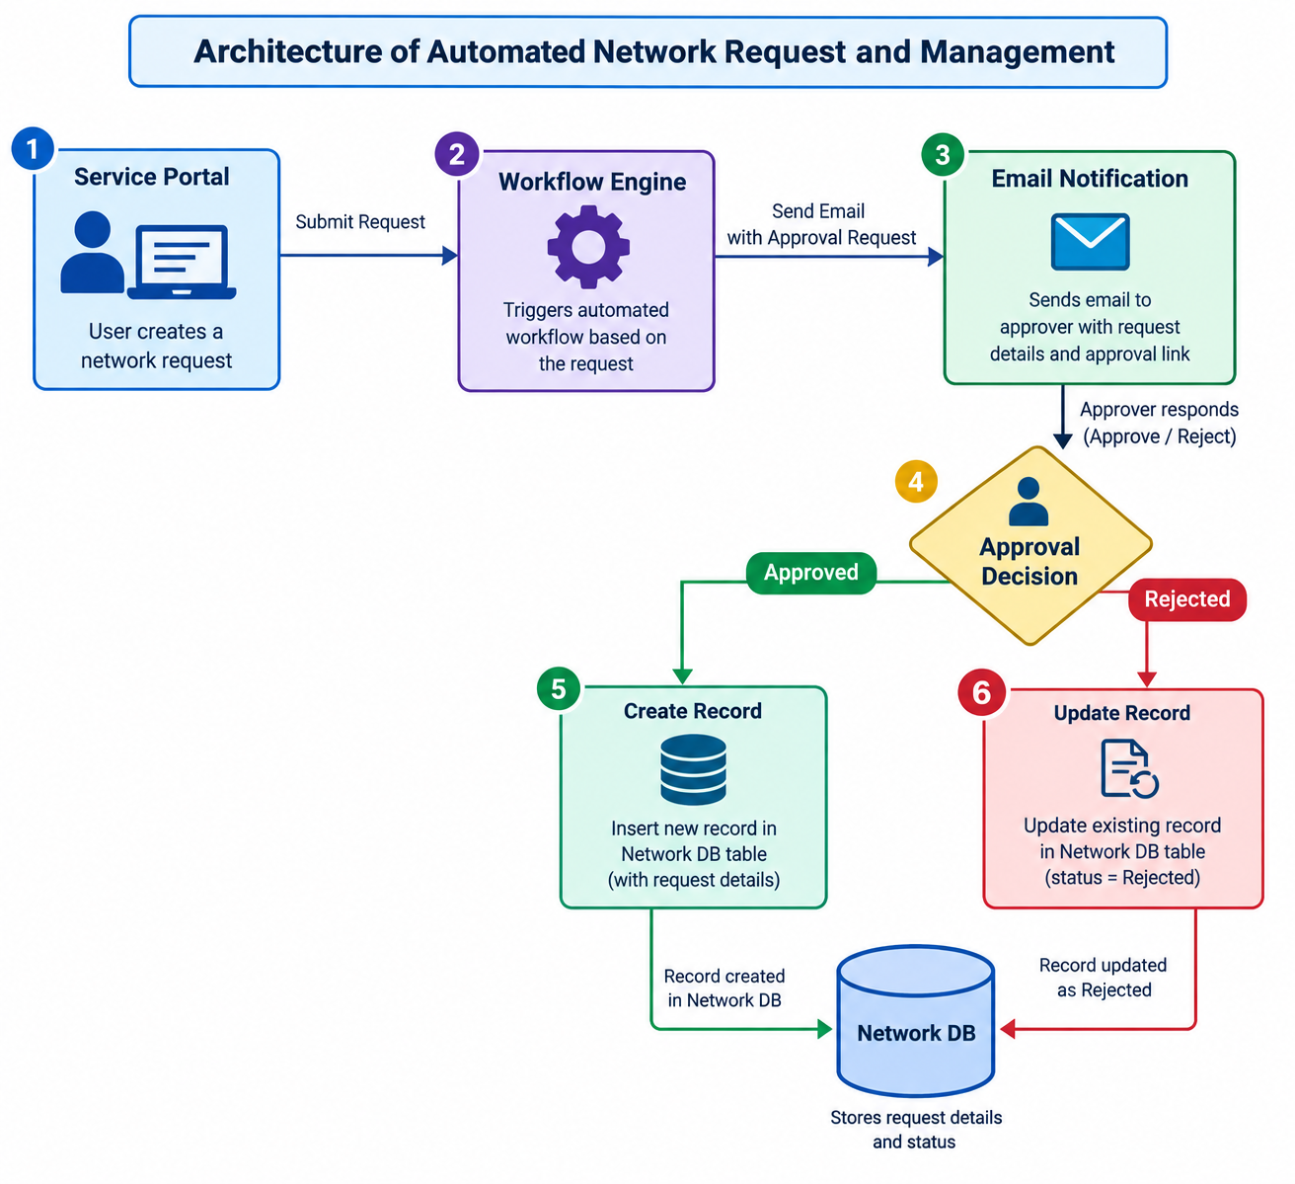

Figure 1: Architecture and data flow
The proposed architecture automates the complete network request and approval process. The process starts when a user submits a network-related request through the Service Portal. The request is then automatically passed to the Workflow Engine, which manages the subsequent activities.
The workflow sends an email notification to the designated approver containing the request details and approval options. The approver reviews the request and decides whether to approve or reject it.
If the request is approved, the workflow automatically creates a new record in the Network DB table with the required request information. If the request is rejected, the workflow updates the corresponding record with a Rejected status.
This automated approach reduces manual processing, improves request tracking, and ensures that approval decisions and request statuses are consistently maintained in the database.
Process Flow:
Service Portal → Workflow Engine → Email Notification → Approval Decision → Network DB

